**Space Invaders**

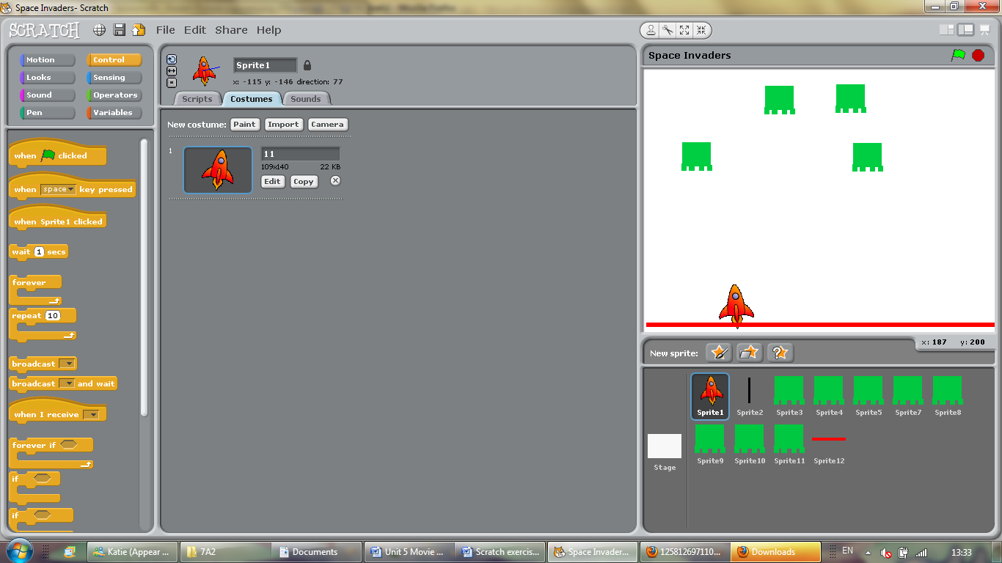In Scratch you can create a space invaders game by following these steps

**Objectives**

1. To understand how to create complex if commands
2. To learn how to create a complete game

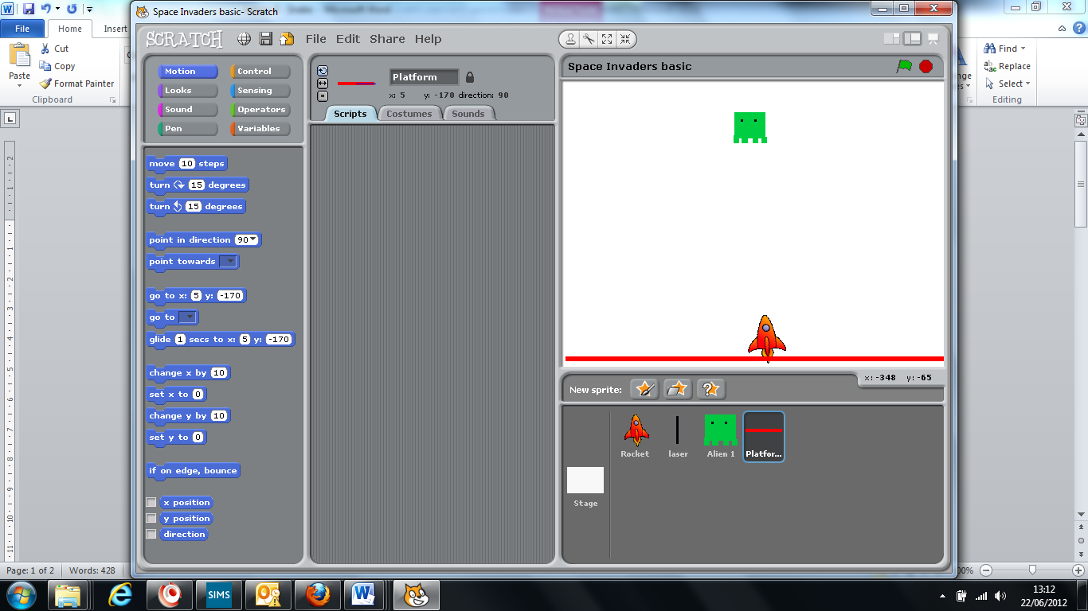**Step 1:** Create 4 sprites

 A rocket. You will control this using the arrows

A laser. You will control this using the space bar (this should be approx 2/3 cm long)

 A platform. This will sense whether the aliens touch the base.

 An Alien. This is what you will be shooting.

**Step 2:** controlling the rocket

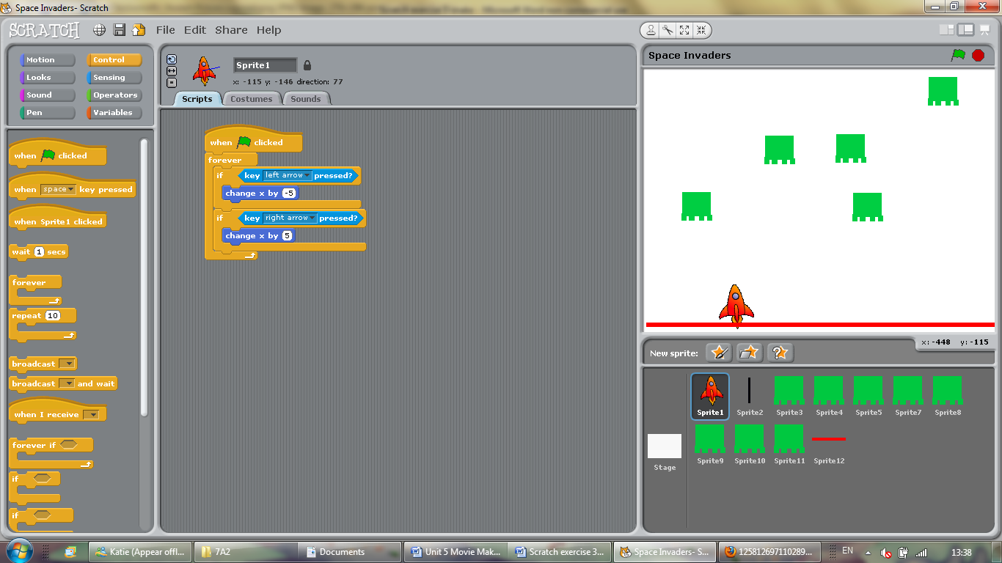You need to be able to control the rocket using the left and right buttons. The rocket must be able to move freely from left to right.

Enter these sequences on your rocket sprite

When the green flag is clicked the program will identify whether the left of right arrows have been pressed. If they have, the rocket will move the desired direction.

**Step 3:** Firing the laser

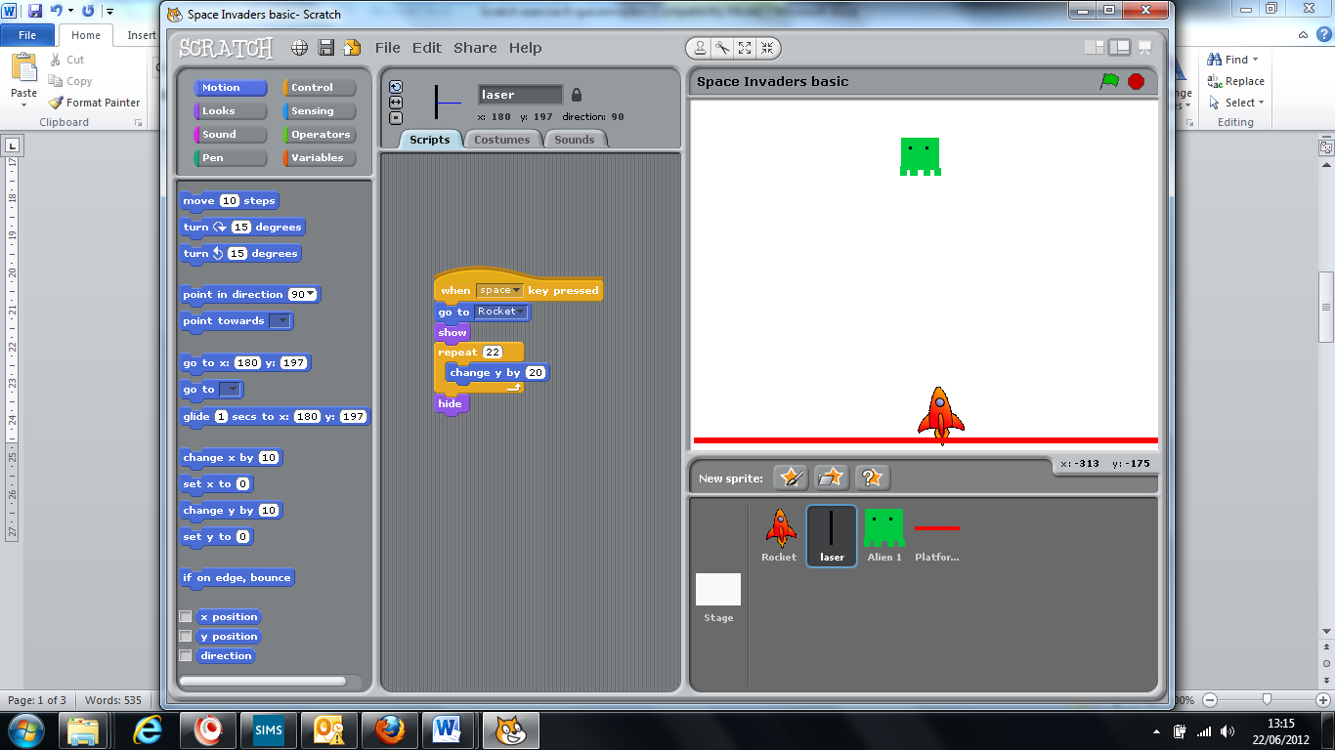You must create a command to shoot lasers when the space bar is pressed.

This sequence identifies when the space bar has been pressed. This will then identify wherever the rocket ship is currently located, show the laser in that location and release it so that it shoots upwards before hiding again. This is important as it will clear any previous games.Enter this sequence on your laser sprite.

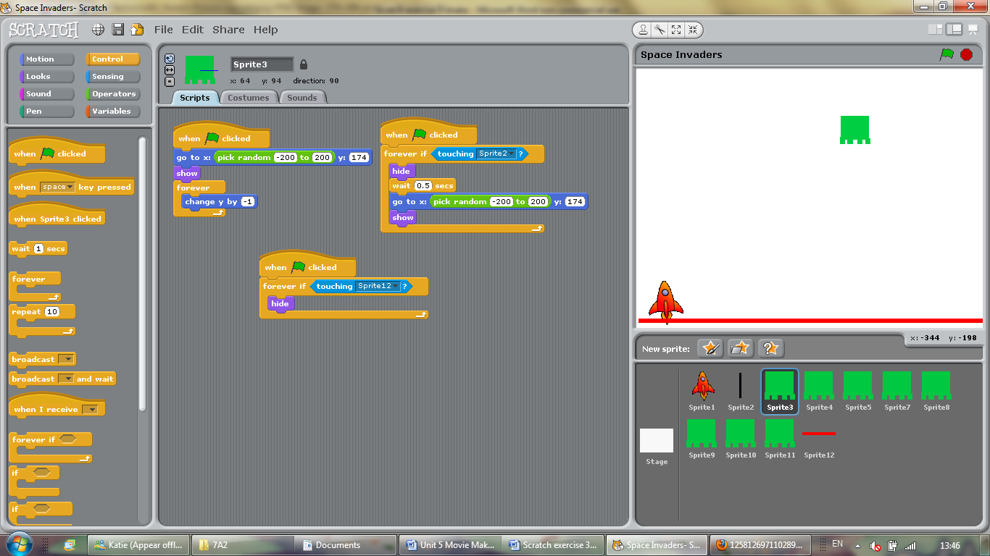**Step 4:** Moving the alien

You must make your alien move down the screen, like in the real space invaders.

When the green flag is clicked, the program picks a random place at the top of the screen. The alien is then shown.

A loop forever command makes the alien automatically move down the screen.

Enter this sequence on your alien sprite

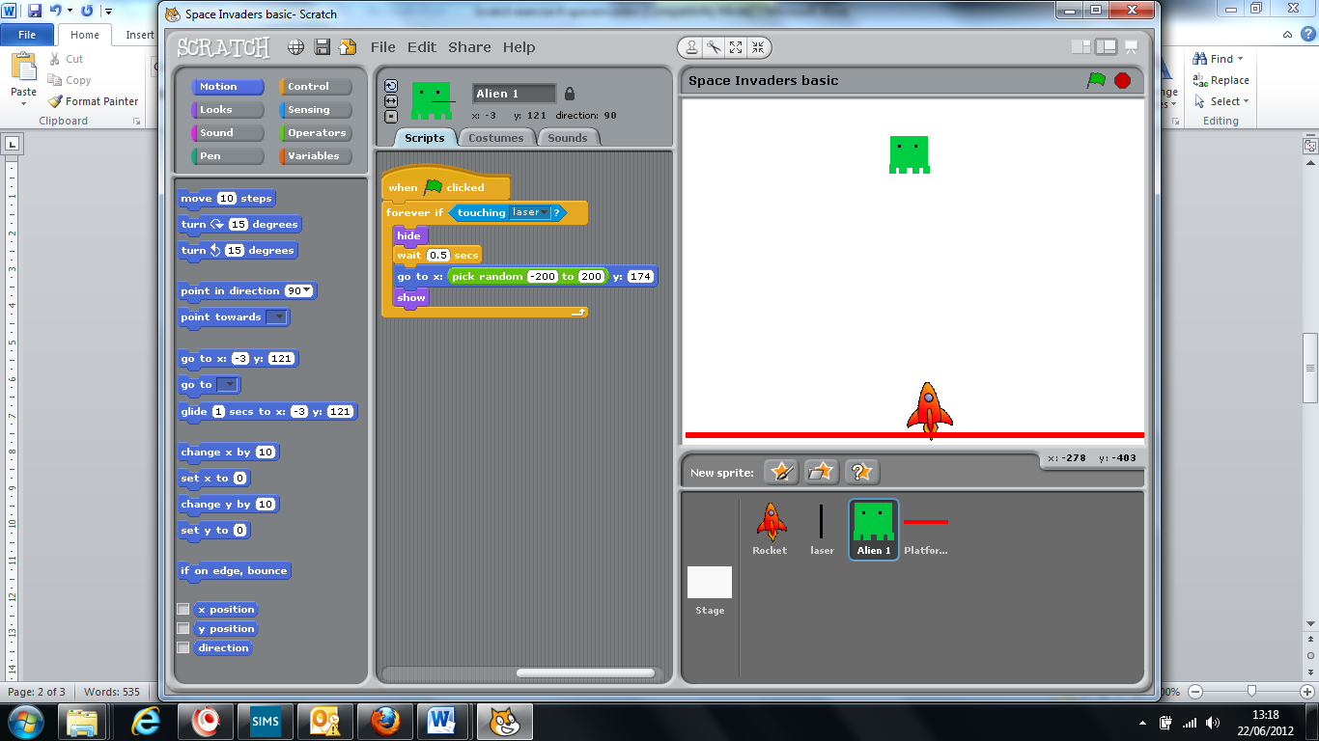**Step 5:** Shooting the alien

You must make sure that the alien disappears when it is hit by the laser.

A loop forever IF command indentifies whether the alien has been touched by the laser

If it has, it will disappear from the screen, wait 0.5 seconds, and reposition itself at a random point at the top of the screen before appearing again. This way, the game works in a continuous loop.

**Step 5:** What if the aliens reach the bottom?

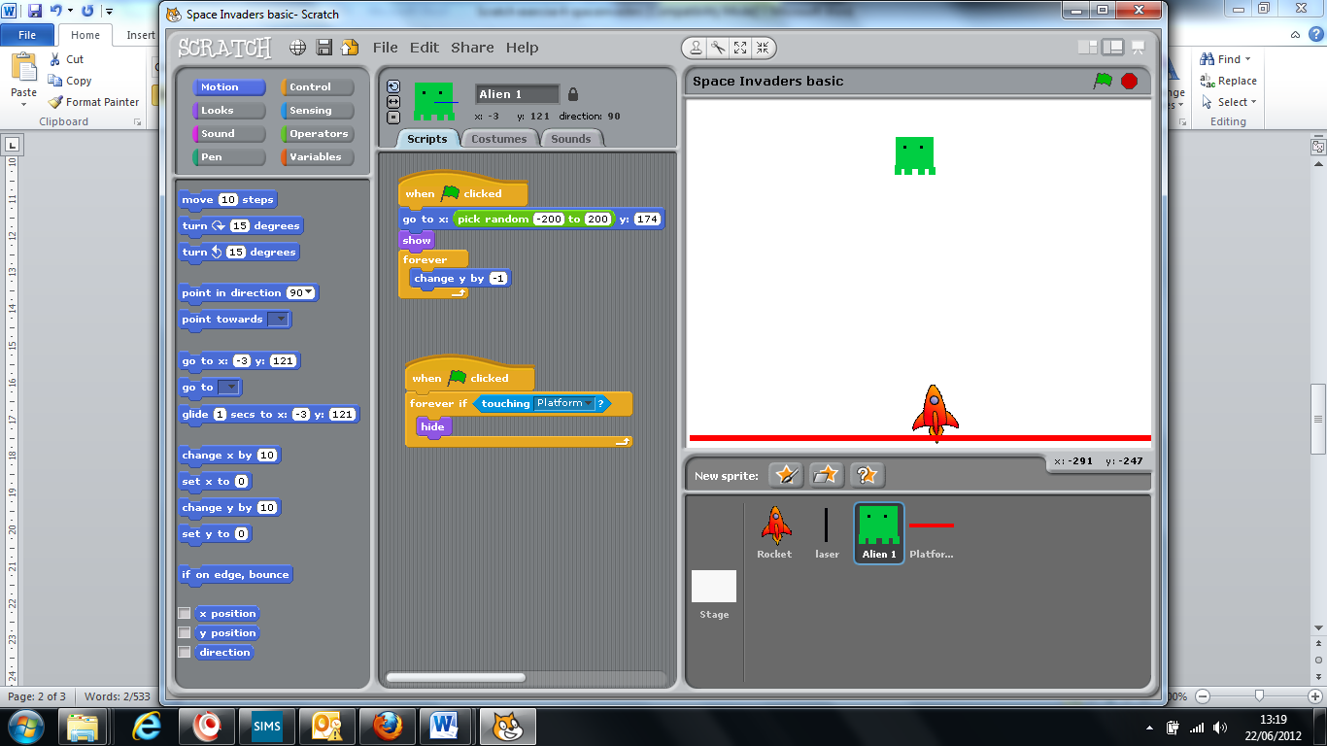You must include a command to signify when the aliens reach the bottom.

This command identifies whether the alien is touching sprite 12 (the red barrier). If it is, the alien will hide.  
**Extension Tasks**

* 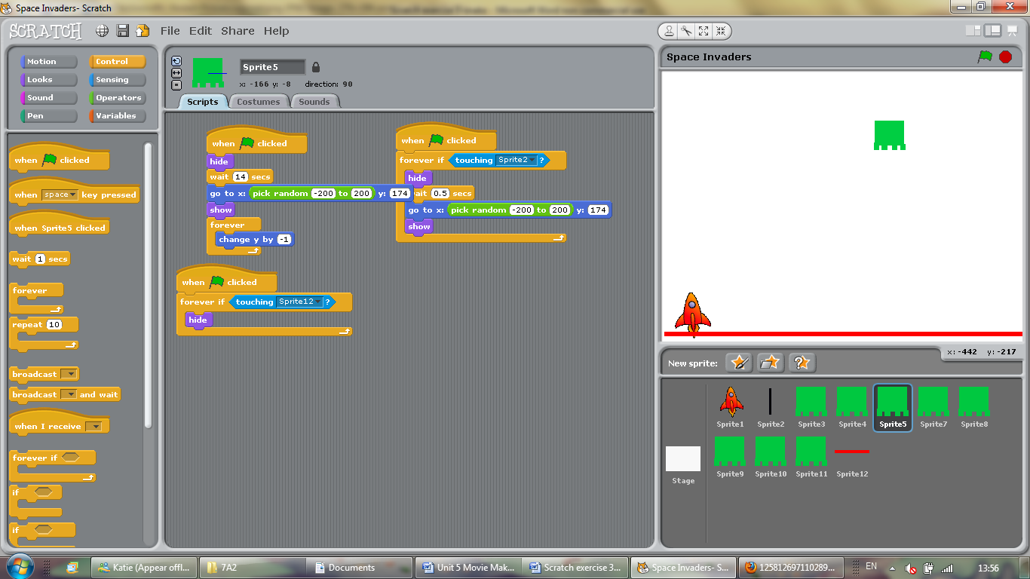Create more elaborate alien/rocket designs.
* Design a space scene background
* Duplicate the aliens so that you have more than one appearing on the screen at once. You could include a command like this so that each alien is staggered to appear at different times, so that the game gets harder and harder.
* Create a more dramatic ending to the game. If the alien reaches the bottom, a GAME OVER message could appear, or the rocket could blow up (by changing the costume)
* Create a score, so that each time the alien is hit the score will go up by 1
* Make the game get harder as you progress. Do more aliens appear? Do they move faster?